

**Test Plan For:**

Simple Food Solutions web application and web service

**Prepared by:**

Amit Kohli

May 1, 2018

Table of Contents

Contents

INTRODUCTION 3

TASKS 3

TESTING ENVIRONMENT 3

TEST CASES 3

RESOURCES/ROLES & RESPONSIBILITIES 3

SCHEDULE 3

SCREENSHOTS 4

## INTRODUCTION

Two applications will be tested. The first being a RESTful web service and the second being a web application that uses the web service.

## TASKS

* Perform unit tests on the following modules for the web application:
  + User account module
  + Recipe search module
  + Report module
  + Web interface
* Perform the following unit tests on the web service
  + Retrieve recipe by keyword
  + Retrieve recipe by id

## TESTING ENVIRONMENT

Tests will be conducted in the Intellij IDEA environment using Maven, Junit 5, and JWebUnit. Tests will be stored in src/test/java location. Unit tests will **not** be deployed into production.

## TEST CASES

Two cases will be tested for each unit test. The first case will represent a successful outcome and the second case will represent a failed outcome

## RESOURCES/ROLES & RESPONSIBILITIES

Amit Kohli (Administrative user) will perform all the necessary test tasks such as test script creation and running. Other people will be used to perform usability testing tasks.

## SCHEDULE

|  |  |  |  |
| --- | --- | --- | --- |
| Test | Testing type | Description | Dates |
| Web service | Functional Testing | Test the web service with Postman API Tool | 4/29 |
| Web Interface | Usability testing | Let users try out the prototype and determine if changes are needed | 5/8 – 5/9 |
| Recipe Search | Functional testing | Test the functionality of searching for recipes | 5/17 - 5/18 |
| User Account | Functional testing | Testing the functionality to create and log into accounts | 5/29 -5/30 |
| Report | Functional Testing | Test the functionality to generate reports | 6/8 -6/9 |

## SCREENSHOTS

**Success Test Case for Login**

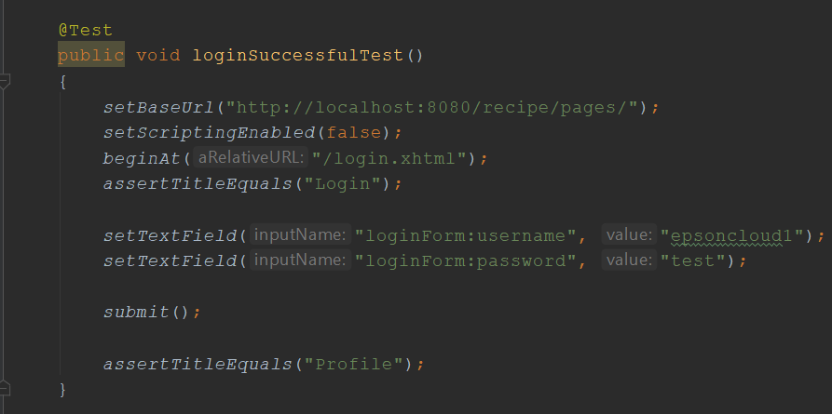

**Failed Test Case for Login**

